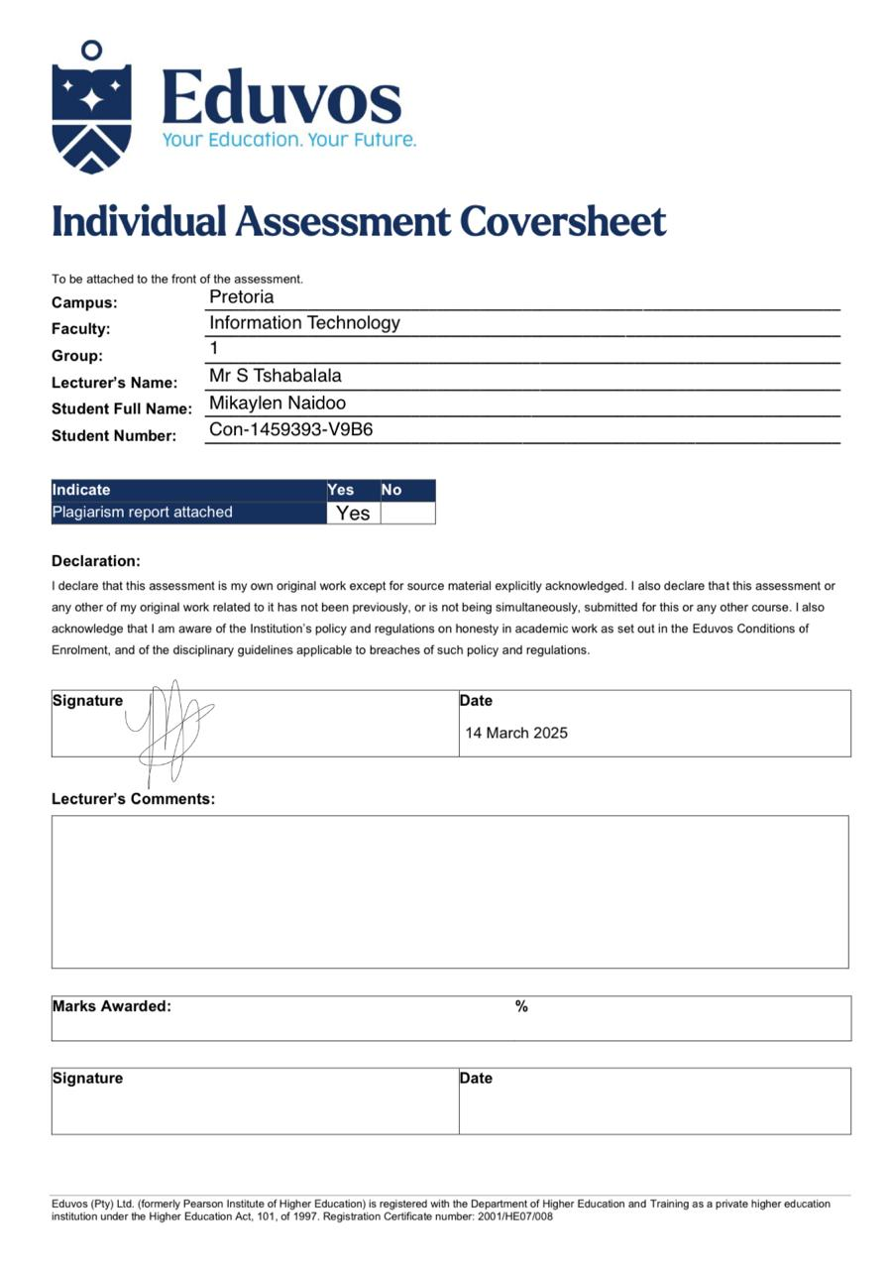

**Question 1:**

u

**References:**

1. **R for Data Science** by Hadley Wickham and Garrett Grolemund: A comprehensive guide to using R for data science, covering data manipulation, visualization, and modeling. (<https://r4ds.hadley.nz/>)
2. **ggplot2: Elegant Graphics for Data Analysis** by Hadley Wickham: A book dedicated to the ggplot2 package, essential for creating informative and aesthetically pleasing visualizations in R.
3. **Shiny Documentation**: The official documentation for the Shiny R package, providing guidance on building interactive web applications. (<https://shiny.rstudio.com/>)
4. **Mastering Shiny** by Hadley Wickham: An in-depth resource for learning advanced Shiny techniques and best practices. (<https://mastering-shiny.org/>)
5. **R Markdown: The Definitive Guide** by Yihui Xie, J.J. Allaire, and Garrett Grolemund: A guide to using R Markdown for creating dynamic documents and reports.
6. **"The Art of Data Visualization"** by Kirk Borne: A blog post discussing the principles and best practices of data visualization.
7. **"Data Visualization: A Practical Introduction"** by Kieran Healy: Provides a broad overview of data visualization principles and techniques.
8. **Journal of Data Science**: A peer-reviewed journal publishing research on statistical methods and data analysis.
9. **"Data Cleaning with R"** by Edwin de Jonge and Mark van der Loo: A paper focusing on practical techniques for cleaning data using R.
10. **Tidyverse Style Guide**: Official style guide for the Tidyverse suite of packages, promoting consistency and readability in R code. (<https://style.tidyverse.org/>)
11. **"The State of AI in 2024"** by McKinsey: Provides insights into AI adoption trends across industries.
12. **"AI Index Report 2024"** by Stanford University: A comprehensive report tracking trends in artificial intelligence.
13. **"The Future of Jobs Report 2023"** by World Economic Forum: Outlines the skills and jobs of the future, including those related to technology.
14. **Stack Overflow Developer Survey 2024**: Insights into the tools and technologies used by developers worldwide.
15. **KDnuggets**: A leading site for data science and machine learning, offering tutorials, articles, and news.
16. **Towards Data Science**: A Medium publication with articles on data science, machine learning, and AI.
17. **"A Comprehensive Guide to Data Exploration"** by Susan Li: A blog post covering essential techniques for exploring and understanding data.
18. **"Effective Data Storytelling: How to Drive Action with Data"** by Brent Dykes: A guide to communicating insights effectively through data storytelling.
19. **R Graphics Cookbook** by Winston Chang: Provides recipes for creating various types of graphs using R.
20. **Blogdown: Building Websites with R Markdown** by Yihui Xie, Amber Thomas, and Alison Hill: A guide to creating websites using R Markdown and blogdown.